CS 255 System Design Document

Alan Abraham Puthenparambil Kochumon
CS255: System Analysis and Design
DriverPass System Project

UML Diagrams

UML Use Case Diagram
UML Activity Diagram (Purchasing Package)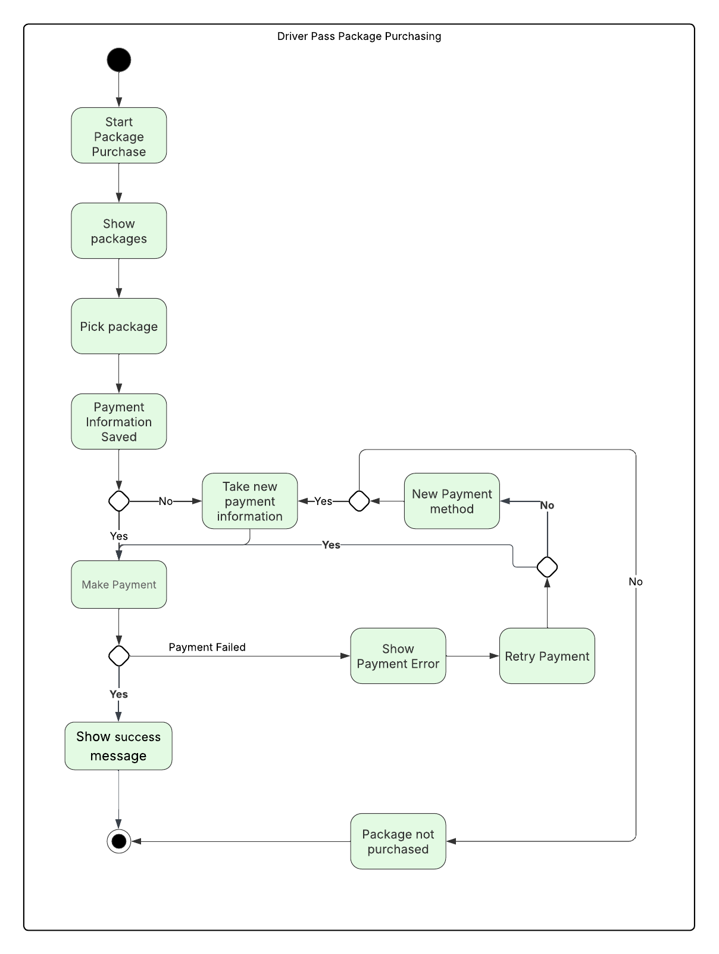
UML Activity Diagram (Lesson Scheduling)
UML Sequence Diagram (Purchasing Package)

UML Class Diagram

Technical Requirements
For DriverPass, the system needs to be a web-based application hosted in the cloud so it can be accessed from anywhere and on all major browsers. This requires a web server and application server stack (for example, a cloud VM or container cluster), a relational database for storing user, schedule, and package data, and secure HTTPS/TLS termination at the load balancer or web server. Because Liam does not want to manage backups or security himself, the infrastructure should use managed cloud services with automated backups, redundancy, and role-based access to the production environment. Reports can be generated by the application and exported to formats like PDF or CSV so Liam can download and view them offline on any device.
From a software and security perspective, the system must implement role-based access control so that Students, Drivers, Secretaries, IT Admins, and the Owner each see only the features relevant to their job. This will be enforced in the web application layer and the database using user roles, permissions tables, and secure password hashing. A comprehensive auditing and logging mechanism is required, using an application log store or centralized logging service to track every creation, update, and cancellation of lessons, as well as admin actions. These logs must be queryable for reports and export.
Several technical components support the core business logic. A lesson scheduling engine is needed to manage time slots, drivers, and vehicles, with server-side validation to prevent double-booking. Package management functionality must allow the Owner to enable or disable packages through the admin UI without changing code, which implies configuration tables in the database and corresponding admin screens. For payments, the system will integrate with a secure third-party payment gateway; payment methods will be stored using tokenization where possible, and all payment traffic must be encrypted and PCI-aware. Finally, a notification subsystem (for example, email/SMS integration or in-app notifications) is required so Liam and other users can be alerted when lessons are scheduled, updated, or canceled. Development tools would include a modern web framework, version control (such as Git), an issue tracker, and a CI/CD pipeline to deploy safely to the cloud environment.

